**Project Design Phase-II**

**Technology Stack (Architecture & Stack)**

|  |  |
| --- | --- |
| **Date** | **26 June 2025** |
| **Team ID** | **LTVIP2025TMID31972** |
| **Project Name** | **HealthAl: Intelligent Healthcare Assistant Using IBM Granite** |
| **Maximum Marks** | **4 Marks** |

**Technical Architecture:**

The Deliverable shall include the architectural diagram as below and the information as per the table1 & table 2

**AI-Enabled Healthcare Assistance for Remote or Rural Areas (Offline or Low Connectivity Mode)Reference:** [**https://developer.ibm.com/patterns/ai-powered-backend-system-for-order-processing-during-pandemics/**](https://developer.ibm.com/patterns/ai-powered-backend-system-for-order-processing-during-pandemics/)

Guidelines:

Include all the processes (As an application logic / Technology Block)

Provide infrastructural demarcation (Local / Cloud)

Indicate external interfaces (third party API’s etc.)

Indicate Data Storage components / services

Indicate interface to machine learning models (if applicable)

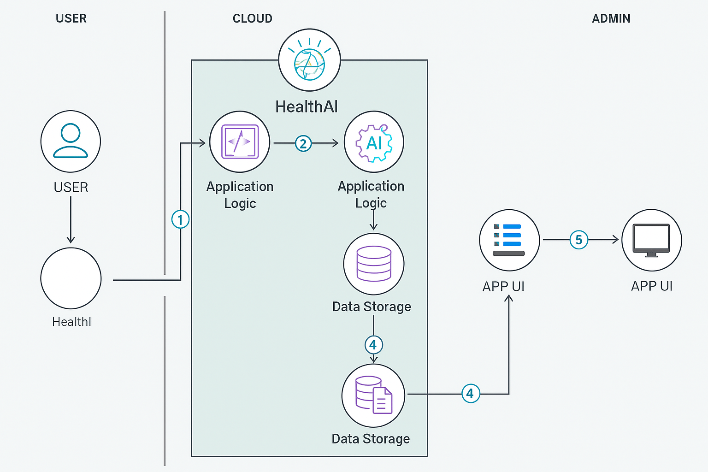

|  |  |  |  |
| --- | --- | --- | --- |
| **S.No** | **Component** | **Description** | **Technology** |
|  | User Interface | Web-based interface for patients to interact with features (chat, prediction, analytics) | Streamlit (HTML/CSS), Bootstrap, Python |
|  | Application Logic-1 | Core logic handling user inputs and managing routing between modules | Python (Flask or native Streamlit logic) |
|  | Application Logic-2 | Speech-to-text conversion (if voice-based input is supported) | IBM Watson STT (optional integration) |
|  | Application Logic-3 | AI-driven medical chat responses and guidance | IBM Watson Assistant / IBM Granite 13B |
|  | Database | Store user profiles, symptoms, medical records, logs | SQLite / PostgreSQL / NoSQL (MongoDB) |
|  | Cloud Database | Cloud-hosted, scalable storage for user and health data | IBM Cloudant / IBM DB2 |
|  | File Storage | To store health reports, analytics snapshots, user uploads | IBM Cloud Object Storage / Local Filesystem |
|  | External API-1 | Optional: real-time health/weather alerts affecting health | IBM Weather API / WHO Health Updates |
|  | External API-2 | Optional: Identity verification or KYC | Aadhar API / Gov Auth APIs |
|  | Machine Learning Model | Powering symptom prediction, treatment plans, and analytics insights | IBM Granite-13B Instruct v2 (Watson ML) |
|  | Infrastructure (Server / Cloud) | Deployment of the entire HealthAI application | IBM Cloud, Kubernetes, Cloud Foundry, or Render |

**Table-1 : Components & Technologies:**